**SQL ASSIGNMENT – 5**

#### 1)  Write an SQL query to print details of workers excluding first names, “Vipul” and “Satish” from Worker table.

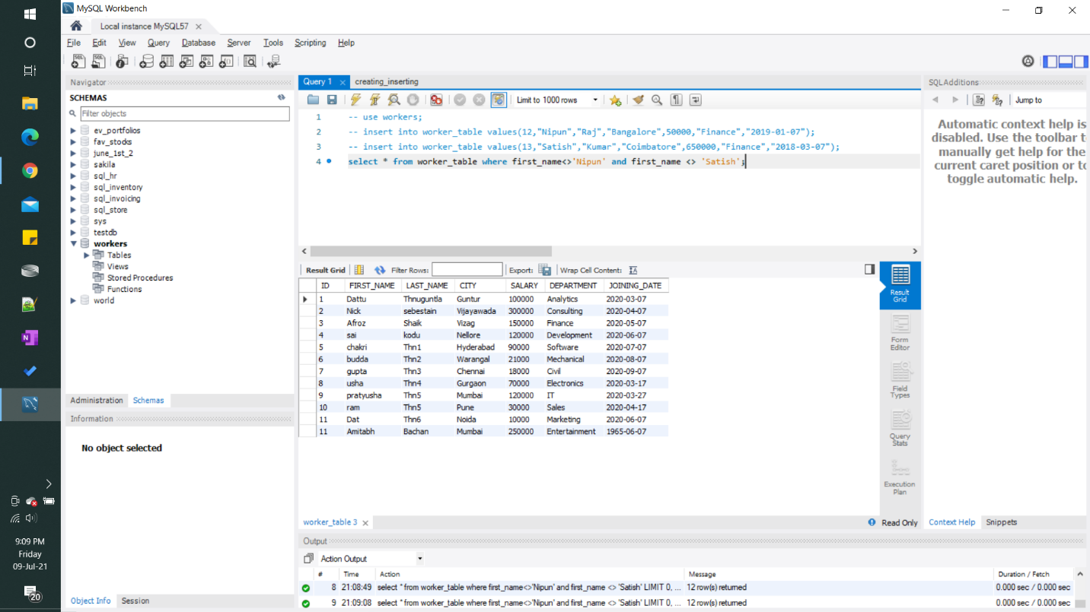

#### 2)  Write an SQL query to print details of the Workers whose FIRST_NAME ends with ‘h’ and contains six alphabets.

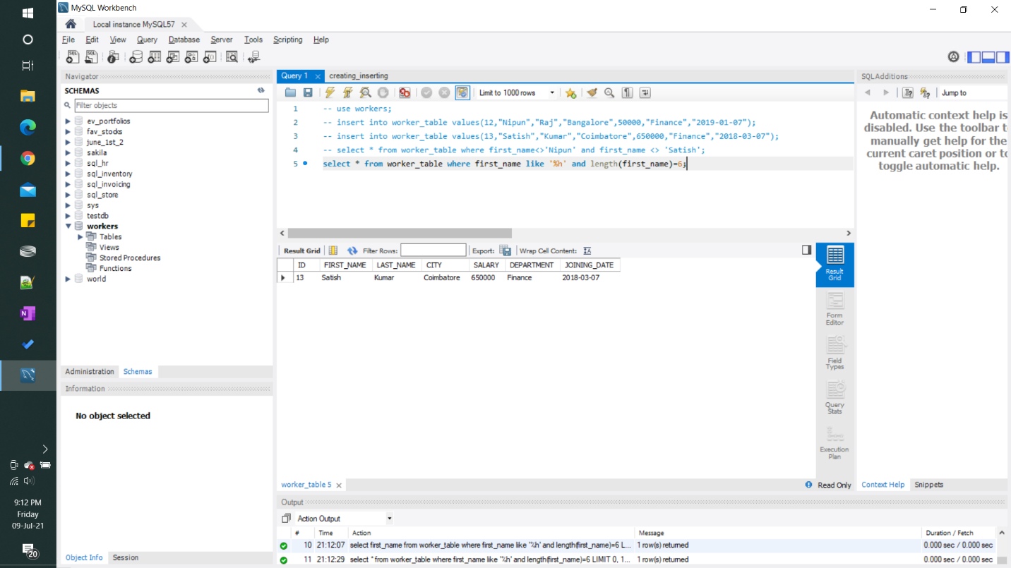

3) **Write a query to validate Email of Employee.**

